Hi Sunny –

The graph will be very similar to one of our previous versions from a few days ago.

For this one, I would like to graph the “total_titles” values from the dataframe on the graph. The only catch is that the total titles amount will then have 10 subtracted to it. This is because the top 10 is already represented in each stacked bar… so I’m trying to communicate to the viewer the quantity of total titles that remain after the top 10. Please see the vision representation below:

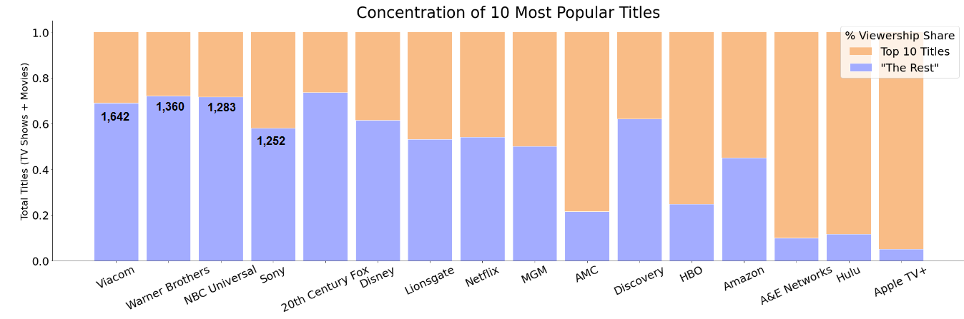

For this version, I would like to have the y-axis scale be between 0 and 100%. Is it possible to do the following please?...

* Change the y-axis label so that “Total Titles” and “(TV Shows + Movies)” is on two lines?
* Change the scale so that the labels are 0%, 20%, 40%, 60%, 80% and 100% (as opposed to their current format of 0, .2, .4, .6, .8 and 1)?